Student Course Performance Analytics using MapReduce (Avro + Combiner + Partitioner)
Task 1:-
Here I created a student dataset using nano editor and stored it in a text file. Then, we created an input directory in HDFS and uploaded the dataset using Hadoop commands. Finally, we verified the file using the hdfs dfs -ls command to ensure successful storage.
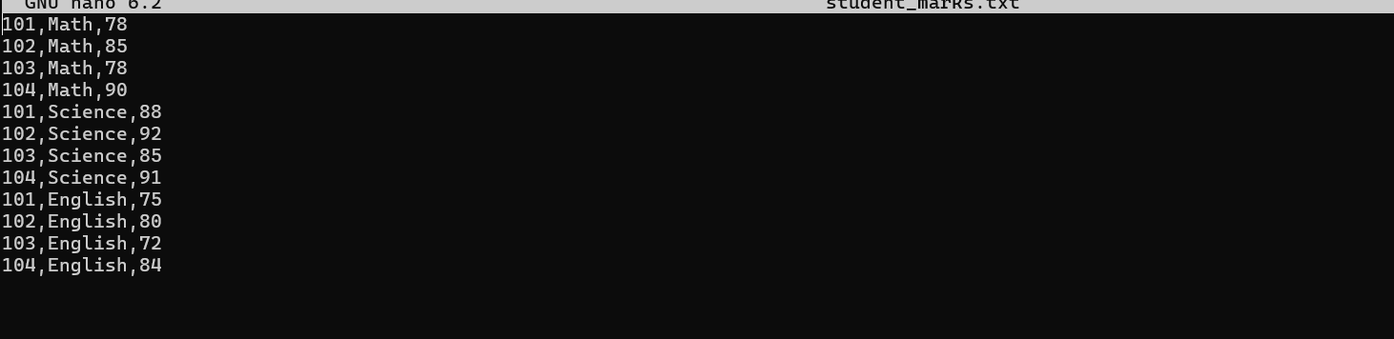
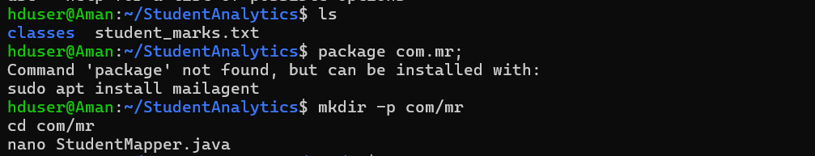
Task-2
In this task, we implemented the core components of the Hadoop MapReduce program, namely the Mapper and Reducer, to process student academic records.

Task 3
In this task, optimization techniques were introduced in the MapReduce workflow by implementing a Combiner and a Partitioner. These components improve performance and ensure efficient data processing.
Task-4
In this task, the MapReduce program was compiled, executed in Hadoop, and the output was analyzed to understand how course-wise academic data is processed.
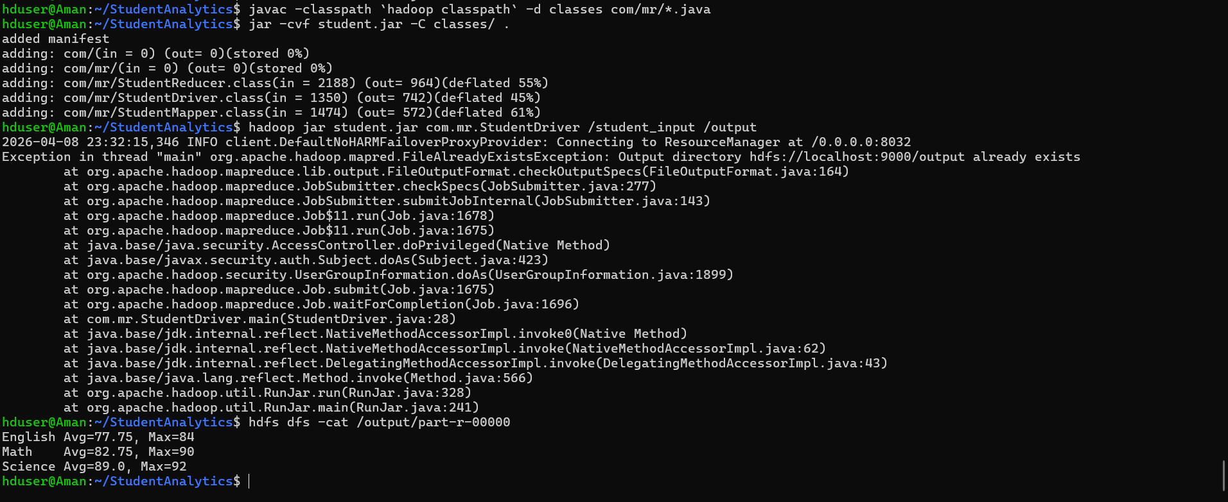
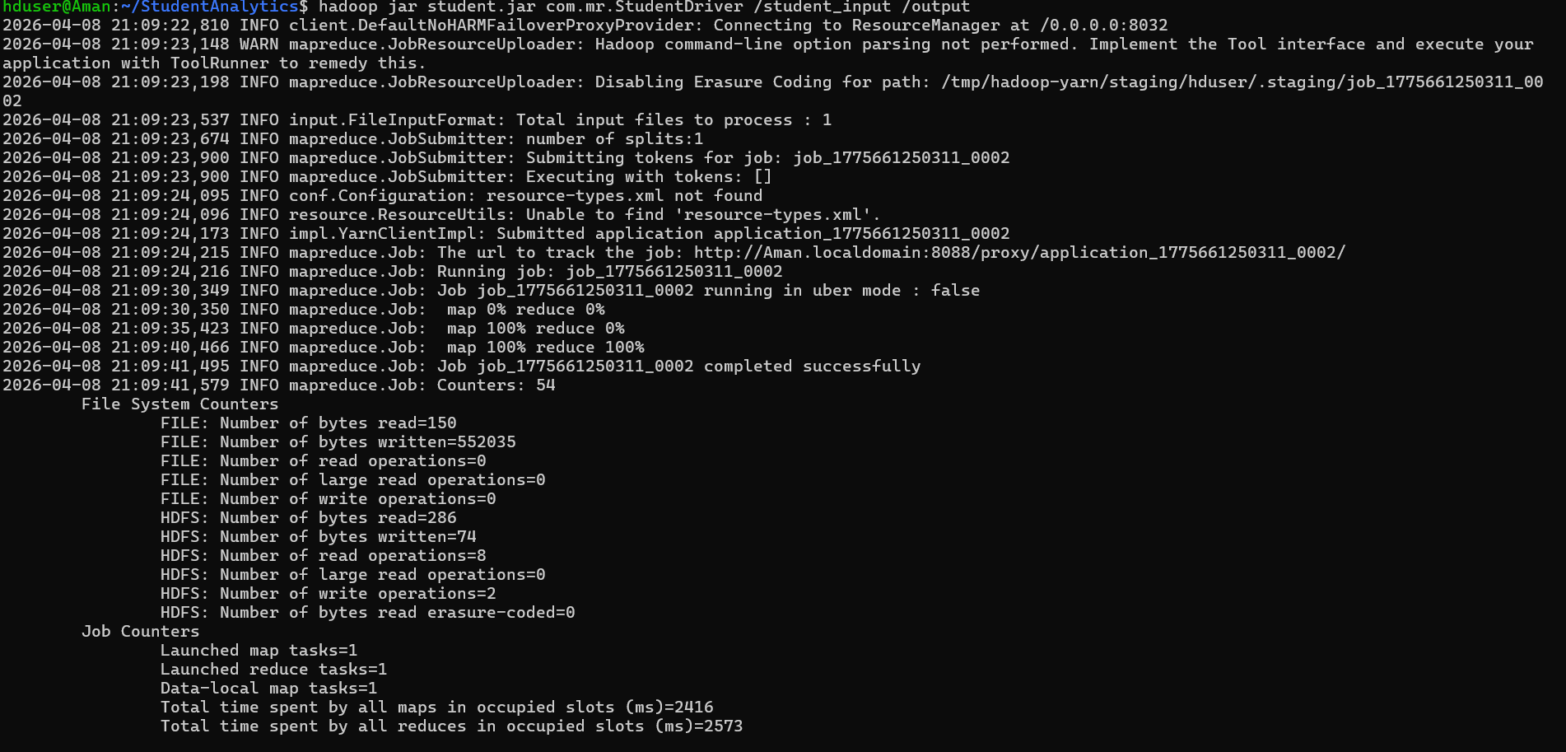
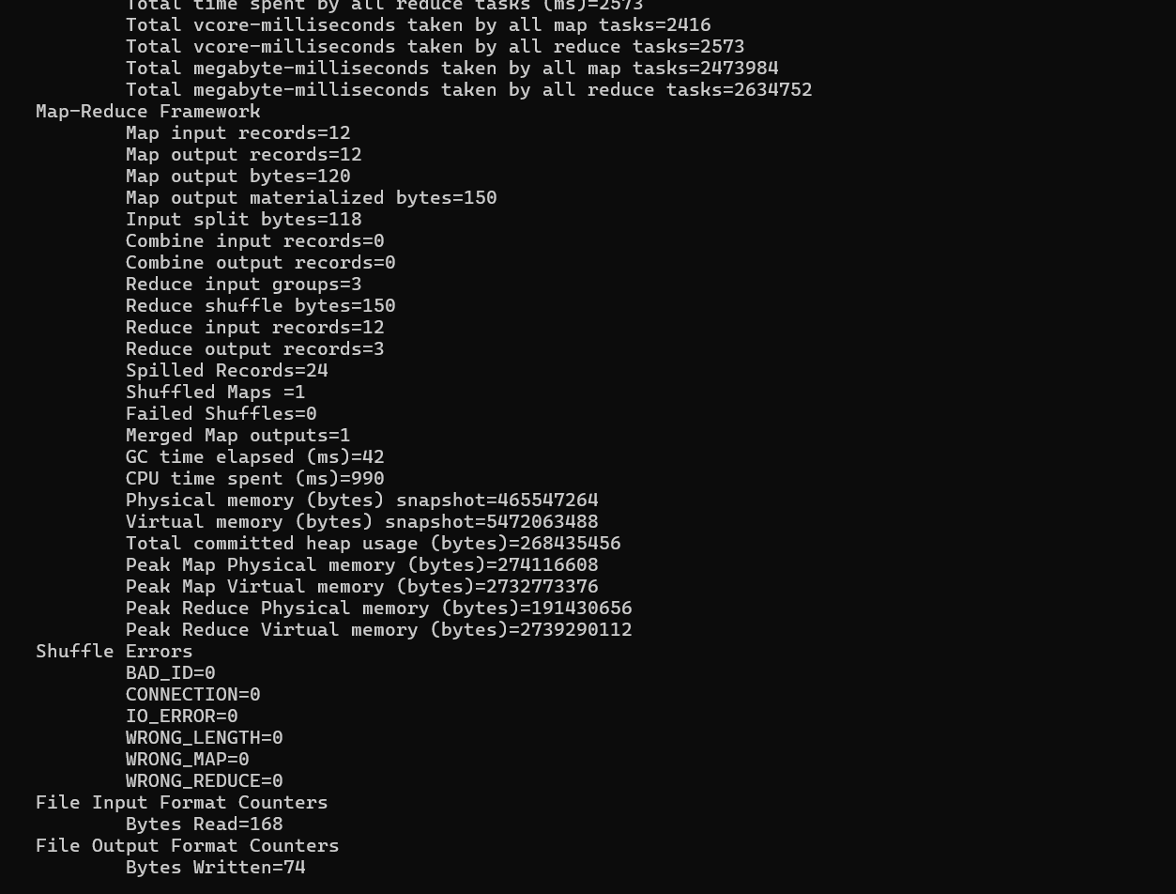
Github-

